Question 4:

PAC:

*PAC Chart:*

|  |  |  |  |
| --- | --- | --- | --- |
|  | *Given Data*   * *Card 1* * *Card 2* * *Card 3* * *Card 4* * *Card 5* |  | Required Results Output full house or not |
|  | Processing Needed   * Compare all the cards * Use if else statements (use AND and OR operators) * Compare all cards and verify if the conditions are met for a full house * Ensure the group of 3 and the group of 2 are different |  | Alternative Solutions  An array to store the cards and then count frequencies of each value. |

IPO Chart:

|  |  |  |  |  |
| --- | --- | --- | --- | --- |
| *Input*  • Integers:  c1, c2, c3, c4, c5 | *Processes*     1. Read 5 card values. 2. Compare 3. values to check i If: 4. Three cards are the same, and 5. The other two cards are the same, 6. And the groups are not identical. | | *Module*  *Reference*     1. Read 2. Calculate 3. Calculate 4. Print 5. Control | *Output*       * Output full house * Output not   a full  house |
|  |  | Decide whether the hand is a Full House or Not a Full House. |  |  |
|  | 4. | Output result |  |  |
|  | 5. | End |  |  |

IC Chart:

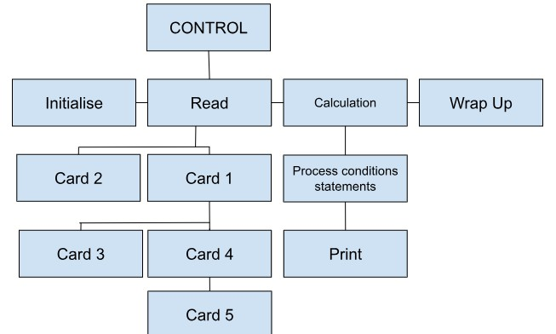

*Flowchart:*

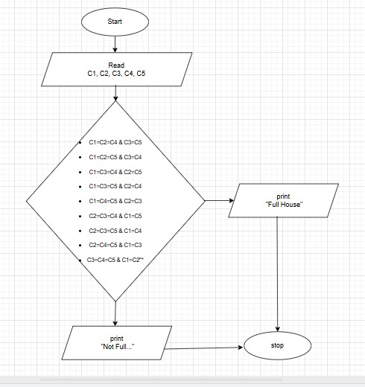

*Algorithm:*

* START
* Declare and input the five cards
* Read all cards
* Compare all the cards for all combinations for a full house
* If any of the above conditions is true
* Display "Full House"
* Else
* Display "NOT a Full House"
* STOP

*Pseudocode:*

Start

Declare c1, c2, c3, c4, c5 as integers

Display "Input all your cards" Read c1, c2, c3, c4, c5

IF (

(c1 = c2 AND c2 = c3 AND c4 = c5 AND c1 <> c4) OR

(c1 = c2 AND c2 = c4 AND c3 = c5 AND c1 <> c3) OR

(c1 = c2 AND c2 = c5 AND c3 = c4 AND c1 <> c3) OR

(c1 = c3 AND c3 = c4 AND c2 = c5 AND c1 <> c2) OR

(c1 = c3 AND c3 = c5 AND c2 = c4 AND c1 <> c2) OR

(c1 = c4 AND c4 = c5 AND c2 = c3 AND c1 <> c2) OR

(c2 = c3 AND c3 = c4 AND c1 = c5 AND c2 <> c1) OR

(c2 = c3 AND c3 = c5 AND c1 = c4 AND c2 <> c1) OR

(c2 = c4 AND c4 = c5 AND c1 = c3 AND c2 <> c1) OR

(c3 = c4 AND c4 = c5 AND c1 = c2 AND c3 <> c1)

)

THEN

Display "Full House"

ELSE

Display "NOT a Full House"

END IF

Stop